Compared K-means clustering with fuzzy clustering (fuzzy c-means clustering, FCM), I think fuzzy c-means is a better method.

Generally speaking, FCM works by assigning membership to each data point corresponding to each cluster center on the basis of the distance between the cluster and the data point. More the data is near to the cluster center more is its membership towards the particular cluster center.

The details of the FCM algorithm are as follows.

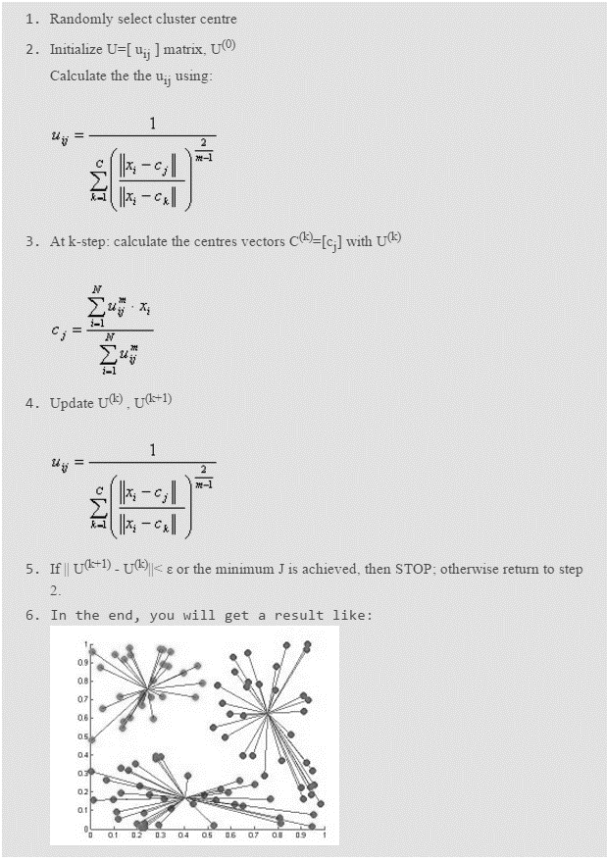

|  |  |  |
| --- | --- | --- |
|  | K-means | Fuzzy C-means (FCM) |
| Objective Function |  |  |

In the K-means method, after randomly selecting initial points, other points can only belong to one cluster according to the distances to initial points, so the result is too sensitive to initial choice. But in the fuzzy clustering, the algorithm gives every point a probability to all initial points, so it doesn’t matter what the initial points are chosen.

Consequently, FCM gives a better result for a data set which is hard to completely and clearly divided into different clusters than k-means.